**YEAR 12 PHYSICS, UNIT 4**

#### Modern Physics Test

#### 

**NAME:** ____________________________________ **TOTAL MARKS: /50**

TIME ALLOWED:50 minutes

INSTRUCTIONS:

Write your answers in the spaces provided beneath each question. The value of each question is shown with each question.

Sufficient working should be provided with a complete, logical, clear sequence of reasoning showing how the final answer was arrived at; correct answers which do not show full working will not necessarily be awarded full marks.

When calculating numerical answers, show your working or reasoning clearly. Give final answers to **three significant figures** where applicable using scientific notation and include appropriate units where applicable.

When estimating numerical answers, or reading off a graph, show your working or reasoning clearly. Give final answers to a maximum of **two significant figures** and include appropriate units where applicable.

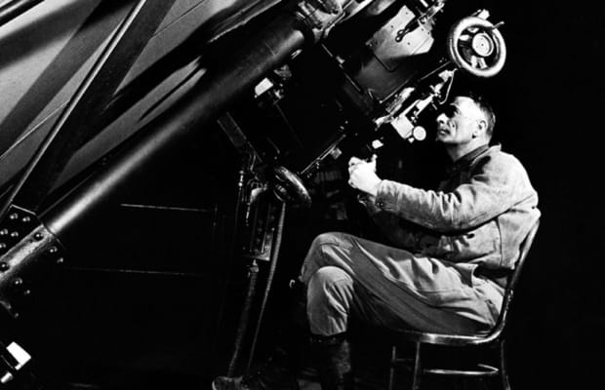

Question 1 (7 marks)

A particle consisting of four quarks and one anti-quark is called a pentaquark. Pentaquarks were theorised as early as 1964 but it wasn’t until 2015 that enough data was gathered to make a genuine claim that a particle that matched the theoretical properties of a pentaquark had been discovered.

1. Calculate the baryon number of a pentaquark. Show your working. [2]

*1 mark for working, 1 mark for answer*

Four quarks at +1/3 each, one antiquark at -1/3 4*1/3 – 1/3 = 1

Baryon number is +1

The equation below describes the formation of a pentaquark. A lambda baryon, $Λ_{b}^{0}$ ($bud$), decays via a W- boson into a kaon minus, $K^{-}$ ($s\overline{u}$), and a pentaquark, $P_{c}^{+}$ ($u\overline{c}cud$).

$$Λ_{b}^{0}→ K^{-}+P_{c}^{+}$$

1. State which fundamental force is responsible for this particle interaction. Justify your choice.

[2]

weak nuclear decay (1)

it is the force associated with the W- boson (1)

1. Show that this decay reaction obeys all conservation laws for particle interactions. [3]

Baryon number: LHS = 1 = RHS = 0 + 1 = 1 (1)

Lepton number: LHS = 0 = RHS = 0 (1)

Charge: LHS = 0 = RHS = -1 + 1 = 0 (1)

**Question 2** [3 marks]

The lowest reported value for the Hubble constant is around 67 km s-1 Mpc-1. Given that 1 parsec (pc) = 3.09 x 1016 m, calculate the age of the universe predicted by this value. Give your answer in years.

Question 3 (5 marks)

a) The diagram left illustrates the repulsion of two electrons. What is the specific particle ‘X’ which is exchanged to carry this electromagnetic repulsive force? [1]

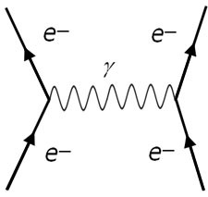

*X*

‘X’

____________________Photon________________________________

b) Another boson is responsible for the force which binds quarks together. What is the name of this force and boson? [2]

Strong nuclear force (1) ; Gluon (1)

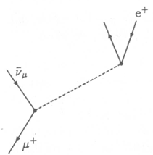

1. 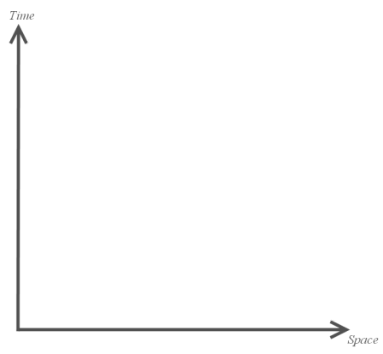The diagram to the right shows the decay of an antimuon. Label the missing particles in the boxes provided. [2]

1 mark per correct particle

Question 4 (8 marks)

Luke is flying his spaceship and attacking the Doom Star, a large energy spaceship. He shoots a rocket with a diameter of 1.00m and a length of 2.00m, measured when the rocket is at rest.

1. An observer on the Doom Star measures the rocket length as 1.25m. How fast is the rocket moving relative to the Doom Star? [3]

$$l = l_{o}\sqrt{(1-\frac{v^{2}}{c^{2}})}=2* \sqrt{1-v^{2}}=1.25$$

$$v=0.781c$$

1 mark for substitution, 1 mark for answer, 1 mark for significant figures

1. The rocket’s onboard computer says that it will take 3.00 seconds from launch to reach the target. In a separate reference frame, the Doom Star has a defensive laser that needs 5.00 seconds to charge. Will it have enough time to intercept the rocket before it reaches the target?

*If you did not calculate a value for 4a, use 0.765c.*  [3]

$t = \frac{t_{o}}{\sqrt{(1-\frac{v^{2}}{c^{2}})}}= \frac{3}{\sqrt{1-{0.781}^{2}}}=4.80 s$ (4.66 if using provided value) No, there is not enough time.

1 mark for substitution, 1 mark for answer, 1 mark for statement that matches answer

1. To complete the mission, the rocket needs to fit into a hole of diameter 0.95m. Luke claims that this isn’t an issue as length contraction means that the rocket will contract and easily pass through the hole.

State whether Luke is correct or incorrect and explain why. [2]

Incorrect (1)

Length contraction only applies in the direction of travel (1) so the diameter is not contracted

**Question 5** (7 marks)

The Big Bang theory describes the history of space-time as starting from a small singularity and expanding into our current universe over around 14 billion years.

1. Describe the phenomenon of redshift and briefly explain its role in providing evidence to support the Big Bang theory. [3]

________________________________________________________________________________

________________________________________________________________________________

________________________________________________________________________________

________________________________________________________________________________

________________________________________________________________________________

________________________________________________________________________________

**Question 6** (2 marks)

State the two postulates of Special Relativity:

________________________________________________________________________________

________________________________________________________________________________

________________________________________________________________________________

________________________________________________________________________________

Question 7 (4 marks)

The Millennium Falcon (shown left, below) and the USS-Enterprise (shown right) are travelling in exactly opposite directions (they are from completely different franchises after all!), as viewed from a third party on some small planet in the Delta Quadrant. The observer measures their speeds as 0.7c (Falcon) and 0.85c (Enterprise). Find:

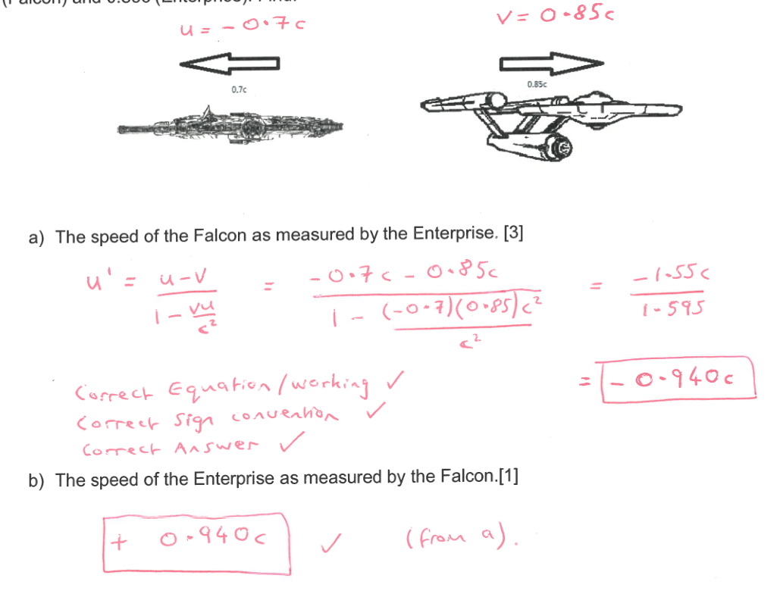

**Question 8** (3 marks)

The average lifetime of a π meson in its own frame of reference is 26.0 ns. A π meson is created from particle interactions in a particle accelerator and travels at a speed of 0.95c relative to the particle accelerator.

Calculate the distance the π meson travels before decaying, as measured by an observer at the particle accelerator.

$t = \frac{t_{o}}{\sqrt{(1-\frac{v^{2}}{c^{2}})}}= \frac{26}{\sqrt{1-{0.95}^{2}}}=83.3 ns$ 1 mark for substitution including correctly identifying to

1 mark for calculating t

distance = v * t = 0.95 * 3*108 * 83.3 * 10-9 = 23.7 m 1 mark for calculating distance

Question 9 (5 marks)

A proton is accelerated in a particle accelerator to a speed of 0.99c.

1. Calculate the total energy of the proton. [2]

$$Et = \frac{mc^{2}}{\sqrt{(1-\frac{v^{2}}{c^{2}})}}= \frac{1.67*{10}^{-27}*{(3*{10}^{8})}^{2}}{\sqrt{1-{0.99}^{2}}}=1.07*{10}^{-9}J$$

1 for substitution, 1 for answer

1. Calculate the additional kinetic energy the proton must obtain to travel at 0.999c. [2]

$E_{t,0.999} = \frac{mc^{2}}{\sqrt{(1-\frac{v^{2}}{c^{2}})}}= \frac{1.67*{10}^{-27}*{(3*{10}^{8})}^{2}}{\sqrt{1-{0.999}^{2}}}=3.36*{10}^{-9}J$ 1 mark

$∆KE = E_{t,0.999}-E_{t,0.99}=3.36*{10}^{-9}-1.07*{10}^{-9}=2.29*{10}^{-9} J$ 1 mark for answer

1. Explain why it is not possible to accelerate the proton to the speed of light. [1]

A proton has mass and it would require infinite energy to accelerate a particle with mass to the speed of light. 1 mark

**Question 10** (6 marks)

Astronaut Gary is floating in space and is surprised to see a Borg Spaceship flying past. He sees it passing at a constant velocity, close to the speed of light. The spacecraft has light 1 at the front and light 2 at the rear. Gary **sees the two lights 1 and 2 illuminate simultaneously** as the ship passes. Hugh is a passenger in the middle of the ship. He also sees the lights.

Given this information, circle the correct statements below for questions a), b) and c).



Gary

Light 1

Light 2



Hugh

motion

1. [2]
2. Gary sees light from 1 *reach Hugh* before light from 2
3. Gary sees light from 2 *reach Hugh* before light from 1
4. Gary sees light from 1 and 2 *reach Hugh* at the same time

Explain your answer

________________________________________________________________________________

________________________________________________________________________________

________________________________________________________________________________

1. Hugh sees light from 1 arrive before 2
2. Hugh sees light from 2 arrive before 1
3. Hugh sees both lights arrive at the same time [1]
4. Hugh concludes that the lights flashed simultaneously
5. Hugh concludes that light 1 flashed before light 2
6. Hugh concludes that light 2 flashed before light 1 [1]
7. Hugh and Gary have identical stopwatches set to countdown from one minute. As Hugh passes Gary, both stopwatches commence their countdown. Hugh states that his stopwatch will finish the countdown first but Gary states the opposite. Explain who is correct and why.[2]

______________________________________________________________________________

______________________________________________________________________________

______________________________________________________________________________

______________________________________________________________________________

**Question 11** (4 marks)

In the Standard Model of particle physics, hadrons are composed of combinations of quarks or antiquarks. Hadrons are further divided into two families: baryons and mesons.

1. Below is a list of the 6 different quarks that make up hadrons.

|  |  |  |  |  |  |  |  |
| --- | --- | --- | --- | --- | --- | --- | --- |
| **NAME** | **SYMBOL** | **Charge (Q)** | **Baryon Number (B)** | **Strangeness (S)** | **Charm**  **(c)** | **Bottomness (b)** | **Topness**  **(t)** |
| *Up* | U | e |  | 0 | 0 | 0 | 0 |
| *Down* | D | e |  | 0 | 0 | 0 | 0 |
| *Strange* | S | e |  | -1 | 0 | 0 | 0 |
| *Charmed* | C | e |  | 0 | +1 | 0 | 0 |
| *Bottom* | b | e |  | 0 | 0 | -1 | 0 |
| *Top* | t | e |  | 0 | 0 | 0 | +1 |

State the composition of the following hadrons:

(i) the antiproton, with Q = -1, B = 0, and S = 0, and c = b = t = 0

uud

(ii) the Lambda-zero $Λ^{0}$ baryon, with Q = 0, B = +1, and S = -1, and c = b = t = 0

uds

(iii) the charmed Xi (Ξ+c) baryon, with Q = +1, B = +1, S = -1, c = +1 and b = t = 0

usc

(iv) the D-zero meson, with Q = 0, B = 0, c = +1 and s = b = t = 0

ūc

**END OF TEST**